**Advance JavaScript assignment**

**Module 1**

**1 Write a program to Show an alert?**

<!DOCTYPE html>

<html lang="en">

<head>

    <meta charset="UTF-8">

    <meta name="viewport" content="width=device-width, initial-scale=1.0">

    <title>Document</title>

</head>

<body>

    <script>

        if ("0") { alert( 'Hello'); }

    </script>

</body>

</html>

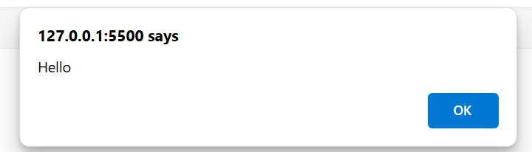

**2 What will be the result for these expressions?**

**1) 5>4**

**True**

**2) “apple” > “mango”**

**False**

**3) “2” > “12”**

**True**

**4) undefined == null**

**True**

**5) undefined == = null**

**False**

**6) null == “\n0\n”**

**False**

**7) null === +”\n0\n”**

**False**

**3 3 Will alert be shown?**

<!DOCTYPE html>

<html lang="en">

<head>

    <meta charset="UTF-8">

    <meta name="viewport" content="width=device-width, initial-scale=1.0">

    <title>Document</title>

</head>

<body>

    <script>

        if ("0") { alert( 'Hello'); }

    </script>

</body>

</html>

**Yes alert will be shown**



**4 What is the code below going to output?**

**alert (null || 2 || undefined);**

**the output will be 2.**

**It display in alert box.**

**2 is true value**

**5 The following function returns true if the parameter age is greater than 18. xOtherwise, it asks for a confirmation and returns its result:**

<!DOCTYPE html>

<html lang="en">

<head>

    <meta charset="UTF-8">

    <meta name="viewport" content="width=device-width, initial-scale=1.0">

    <title>Document</title>

</head>

<body>

    <label for="ageInput">Enter your age</label>

    <input type="number" id="ageInput" name="ageInput">

    <br>

    <br>

    <button onclick="checkAgeContainer()">Submit</button>

    <script>

        function checkAgeContainer() {

            let age = parseInt(document.getElementById('ageInput').value);

            let result = checkAge(age);

        }

        function checkAge(age) {

            if (age > 18) {

                document.write("Age is valid");

                return true;

            } else {

                document.write("Age is not valid");

                return false;

            }

        }

    </script>

</body>

</html>

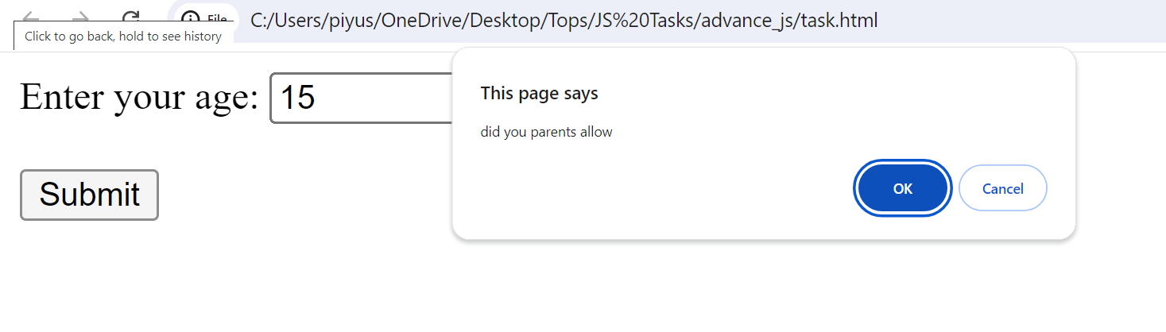

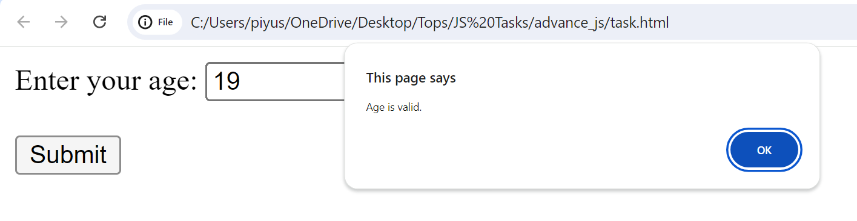

**6 Replace Function Expressions with arrow functions in the code below.**

<!DOCTYPE html>

<html lang="en">

<head>

    <meta charset="UTF-8">

    <meta name="viewport" content="width=device-width, initial-scale=1.0">

    <title>Document</title>

</head>

<body>

    <button onclick="main()">submit</button>

    <script>

        let ask = (quetion,yes,no)=>{

            if (confirm(quetion))yes(); else no();

            };

            let main = ()=>{

                ask ("do you agree",yes,no);

            }

            let yes = () => {

                alert("agrred");

            }

            let no = () => {

                alert("disagreed")

            }

    </script>

</body>

</html>

**Module 2**

**1] Write the code, one line for each action:**

**a)Create an empty object user:**

**=> let user = {};**

**b) Add the property name with the value John.**

**=> let user = {};**

**user.name = 'John';**

**c)Add the property surname with the value Smith.**

**=> let user = {};**

**user.name = 'John';**

**user. Surname = 'Smith';**

**d) Change the value of the name to Pete**

**=> let user = {};**

**user.name = 'Pete';**

**e) Remove the property name from the object.**

**=> let user = {};**

**user.name = 'John';**

**delete user.name;**

**2] Is array copied? let fruits = ["Apples", "Pear", "Orange"]; // push a new value into the "copy" let shopping Cart = fruits; shoppingCart.push("Banana"); // what's in fruits? alert (fruits. Length); //?**

<!DOCTYPE html>

<html lang="en">

<head>

    <meta charset="UTF-8">

    <meta name="viewport" content="width=device-width, initial-scale=1.0">

    <title>Document</title>

</head>

<body>

    <script>

        let frutis = ["Appels","pear","orange"];

        let shophingcart = frutis;

        shophingcart.push("banana");

        document.write(frutis);

        alert(frutis.length);

    </script>

</body>

</html>

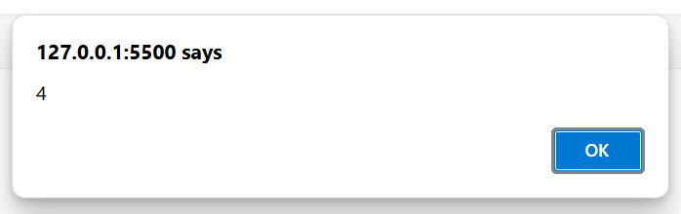

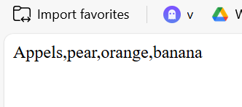

**Q-3Map to names let john = { name: "John", age: 25 }; let pete = { name: "Pete", age: 30 }; let mary = { name: "Mary", age: 28 }; let users = [ john, pete, mary ]; let names = /* ... your code */ alert( names ); // John, Pete, Mary.**

<!DOCTYPE html>

<html lang="en">

<head>

    <meta charset="UTF-8">

    <meta name="viewport" content="width=device-width, initial-scale=1.0">

    <title>Document</title>

</head>

<body>

    <script>

       let john = { name: "John", age: 25 };

       let pete = { name: "Pete", age: 30 };

        let mary = { name: "Mary", age: 28 };

         let users = [ john, pete, mary ];

         let names = users.map(user=>user.name)

          alert( names );

    </script>

</body>

</html>

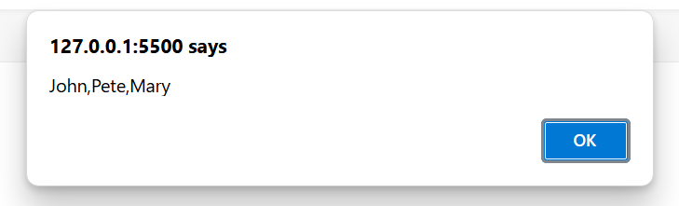

**MODULE: 3**

**Q-1 Create a program to hide/show the password?**

<!DOCTYPE html>

<html lang="en">

  <head>

    <meta charset="UTF-8" />

    <meta name="viewport" content="width=device-width, initial-scale=1.0" />

    <title>Document</title>

  </head>

  <style>

    * {

      margin: 0;

      padding: 0;

      box-sizing: border-box;

      font-family: sans-serif;

    }

    body {

      display: flex;

      align-items: center;

      justify-content: center;

      height: 100vh;

    }

    .container {

      padding: 50px;

      border: 2px solid black;

    }

    h3 {

      margin: 10px;

    }

  </style>

  <body>

    <div class="container">

      <h3>Enter Password : <input type="password" id="pass" /></h3>

      <h3><input type="checkbox" onclick="clicked()" /> show password</h3>

    </div>

    <script>

      function clicked() {

        let a = document.getElementById("pass");

        if (a.type === "password") {

          a.type = "text";

        } else {

          a.type = "password";

        }

      }

    </script>

  </body>

</html>

**Q-2 Create a program that will select all the classes and loop over and whenever i click the button the alert should show**

<!DOCTYPE html>

<html lang="en">

  <head>

    <meta charset="UTF-8" />

    <meta name="viewport" content="width=device-width, initial-scale=1.0" />

    <title>Document</title>

  </head>

  <body>

<div class="class-name">demo</div>

<div class="class-name">demo1</div>

<div class="class-name">demo2</div>

<button id="alertbutton" onclick="main()">show alert</button>

  <script>

     function main(){

      const a = document.getElementsByClassName('class-name');

      let alertmessage = `total number of elements with class 'class-name': ${a.length}`;

      alert(alertmessage);

     }

    </script>

  </body>

</html>

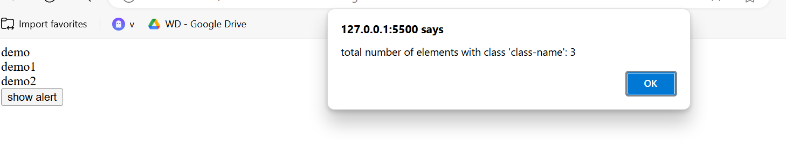

**3 Create a responsive header using proper JavaScript.**

<!DOCTYPE html>

<html lang="en">

<head>

    <meta charset="UTF-8">

    <meta name="viewport" content="width=device-width, initial-scale=1.0">

    <link rel="stylesheet" href="style.css">

    <title>Responsive Header</title>

    <style>

.header {

    overflow: hidden;

    background-color: #f1f1f1;

    padding: 20px 10px;

}

.header a {

    float: left;

    color: black;

    text-align: center;

    padding: 12px;

    text-decoration: none;

    font-size: 18px;

    line-height: 25px;

    border-radius: 4px;

}

.header a.logo {

    font-size: 25px;

    font-weight: bold;

}

.header a:hover {

    background-color: #ddd;

    color: black;

}

.header a.active {

    background-color: dodgerblue;

    color: white;

}

.header-right {

    float: right;

}

@media screen and (max-width: 500px) {

    .header a {

        float: none;

        display: block;

        text-align: left;

    }

    .header-right {

        float: none;

    }

}

#menu-toggle {

    display: none;

}

@media screen and (max-width: 500px) {

    #menu-toggle {

        display: block;

    }

}

    </style>

</head>

<body>

    <header class="header">

        <a href="#" class="logo">Empire Ankit</a>

        <div class="header-right">

            <a href="#home" class="active">Home</a>

            <a href="#contact">Contact</a>

            <a href="#about">About</a>

        </div>

        <button id="menu-toggle">☰</button>

    </header>

    <script>

const menuToggle = document.getElementById('menu-toggle');

const headerRight = document.querySelector('.header-right');

menuToggle.addEventListener('click', () => {

    headerRight.classList.toggle('show-menu');

});

    </script>

</body>

</html>

**4 Create a form and validate using JavaScript**

<!DOCTYPE html>

<html lang="en">

<head>

    <meta charset="UTF-8">

    <meta name="viewport" content="width=device-width, initial-scale=1.0">

    <title>FORM-VALIDATION</title>

</head>

<body>

    <form name="myform" action="" method="post" onsubmit="return validate()">

        <table border="2" align="center">

            <tr>

                <th> Registration Page </th>

            </tr>

            <tr>

                <th>User Fist Name:-</th>

                <td><input type="text" name="ufn"></td>

            </tr>

            <tr>

                <th>User Name:-</th>

                <td>

                    <input type="text" name="un">

                    <span style="color:red" id="un"></span>

                </td>

            </tr>

            <tr>

                <th>Password:-</th>

                <td><input type="password" name="pass"></td>

            </tr>

            <tr>

                <th>Confirm Password:-</th>

                <td><input type="password" name="cpass"></td>

            </tr>

            <tr>

                <th>Email Address:-</th>

                <td><input type="text" name="email"></td>

            </tr>

            <tr>

                <th>Phone No:-</th>

                <td><input type="text" name="pno"></td>

            </tr>

            <tr>

                <th>Hobby</th>

                <td>

                    BGMI <input type="checkbox" name="chk" value="BGMI">

                    MUSIC <input type="checkbox" name="chk" value="music">

                    OUTING <input type="checkbox" name="chk" value="outing">

                    CRICKET<input type="checkbox" name="chk" value="criket">

                </td>

            </tr>

            <tr>

                <th>Gender</th>

                <td>

                    Male <input type="radio" name="gender" value="m">

                    Female <input type="radio" name="gender" value="f">

                </td>

            </tr>

            <tr>

                <td><input type="submit" name="submit" /></td>

            </tr>

        </table>

    </form>

    <script>

        function validate()

        // first name

        {

            var ufn = document.forms["myform"]["ufn"].value;

            if (ufn == "" || ufn == null) {

                alert('fill out')

                return false;

            }

            var alpha = /^[A-Za-z]+$/;

            if (!alpha.test(ufn)) {

                alert('please fill only alpha')

                return false;

            }

            // user name

            var un = document.forms["myform"]["un"].value;

            if (un == "" || un == null) {

                document.getElementById('un').innerHTML = "Please fill out the User Name";

                return false;

            }

            else {

                document.getElementById('un').innerHTML = "";

            }

            // password

            var pass = document.forms["myform"]["pass"].value;

            if (pass == "" && pass == null) {

                alert('fill up')

                return false;

            }

            if (!(pass.length >= 3 && pass.length <= 8)) {

                alert('sarkhi rite lakh')

                return false;

            }

            var cpass = document.forms["myform"]["cpass"].value;

            if (cpass == "" && cpass == null) {

                alert('fill up')

                return false;

            }

            if (pass == cpass) {

            }

            else {

                alert('sarkhi rite lakh bhai bane pass')

            }

            //email

            var email = document.forms["myform"]["email"].value;

            if (email == "" && email == null) {

                alert('enter email')

                return false;

            }

            var mail = /^[a-zA-Z0-9_]+@[a-zA-Z]+\.[a-zA-Z]{2,4}$/;

            if (!mail.test(email)) {

                alert('Please fill proper email id');

                return false;

            }

            //phone number

            var pno = document.forms["myform"]["pno"].value;

            if (pno == "" && pno == null) {

                alert('fill the email')

                return false;

            }

            var phone = /^[0-9]{10,11}$/;

            if (!phone.test(pno)) {

                alert('Please fill only digits in PNO');

                return false;

            }

            // hobby checkbox

            var chk_arr = document.getElementsByName("chk");

            if (chk_arr[0].checked == true) {

            }

            else if (chk_arr[1].checked == true) {

            }

            else if (chk_arr[2].checked == true) {

            }

            else if (chk_arr[3].checked == true) {

            }

            else {

                alert('select any hobby')

                return false;

            }

            //gender radio

            var gender_arr = document.getElementsByName("gender");

            if (gender_arr[0].checked == true) {

            }

            else if (gender_arr[1].checked == true) {

            }

            else {

                alert('ekh choice to krvi padse')

            }

        }

    </script>

</body>

</html>

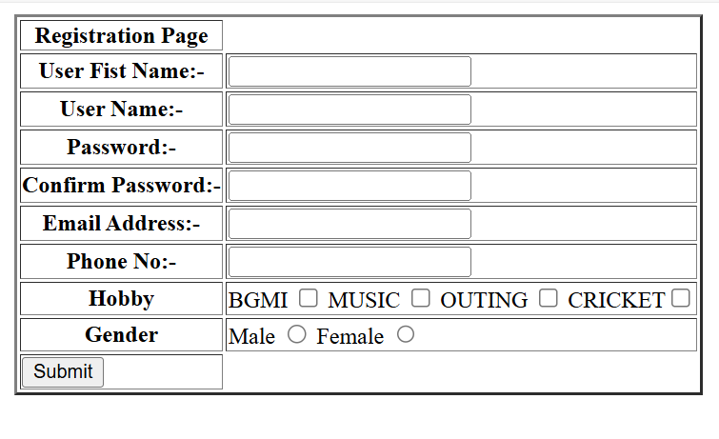

5 Create a modal box using css and Js with three buttons.

<!DOCTYPE html>

<html lang="en">

<head>

    <meta charset="UTF-8">

    <meta name="viewport" content="width=device-width, initial-scale=1.0">

    <title>Modal with Buttons</title>

</head>

<body>

    <button id="openModalBtn">Open Modal</button>

    <div id="myModal" class="modal">

        <div class="modal-content">

            <span class="close">&times;</span>

            <h2>Choose an Action</h2>

            <button class="modal-button">Button 1</button>

            <button class="modal-button">Button 2</button>

            <button class="modal-button">Button 3</button>

        </div>

    </div>

    <script>

const openModalBtn = document.getElementById('openModalBtn');

const modal = document.getElementById('myModal');

const closeModalBtn = document.querySelector('.close');

openModalBtn.addEventListener('click', () => {

    modal.style.display = 'block';

});

closeModalBtn.addEventListener('click', () => {

    modal.style.display = 'none';

});

window.addEventListener('click', (event) => {

    if (event.target === modal) {

        modal.style.display = 'none';

    }

});

    </script>

</body>

</html>

**6 Use external js library to show slider.**

<!DOCTYPE html>

<html lang="en">

<head>

    <meta charset="UTF-8">

    <meta name="viewport" content="width=device-width, initial-scale=1.0">

    <link rel="stylesheet" href="style.css">

    <title>Image Slider</title>

    <style>

.slider-container {

    display: flex;

    overflow: hidden;

}

.slider-container img {

    width: 100%;

    height: auto;

    transition: transform 0.3s ease;

}

    </style>

</head>

<body>

    <div class="slider-container">

        <img src="download (1).jpeg" alt="Image 1">

        <img src="download.jpeg" alt="Image 2">

        <img src="download.jpeg" alt="Image 3">

    </div>

    <script >

const sliderContainer = document.querySelector('.slider-container');

const images = document.querySelectorAll('.slider-container img');

let currentIndex = 0;

function showImage(index) {

    images.forEach((img, i) => {

        img.style.transform = `translateX(${100 * (i - index)}%)`;

    });

}

function nextImage() {

    currentIndex = (currentIndex + 1) % images.length;

    showImage(currentIndex);

}

setInterval(nextImage, 3000);

    </script>

</body>

</html>

**7 Prevent the browser when i click the form submit button**

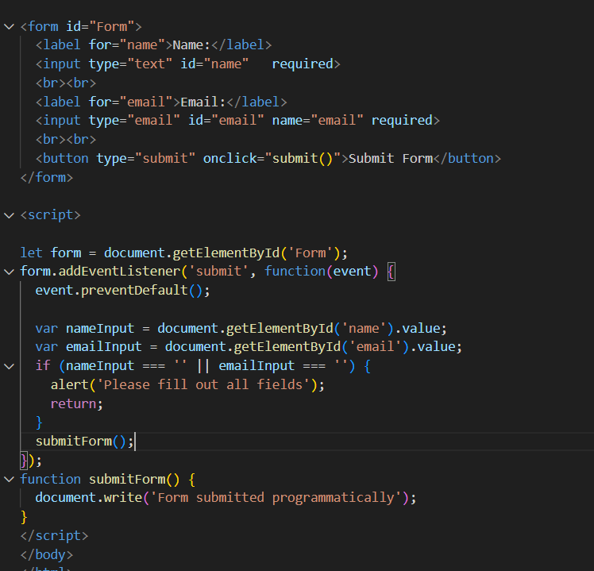

**MODULE: 4**

Q-1 What is JSON

=> json is a javscript object notation

=> json is alight-weight data

=>json is a interchange formate so easy for human read and write

=> json is a transfer data between a server and web application

=> json is build in two structures

1)object

2) arrays

Example of json

"firstName": "John",

"lastName": "Doe",

"age": 30,

Q-2 what is promises

=> Promises are a fundamental concept in JavaScript used for handling asynchronous operations.

=> They provide a more structured way to deal with asynchronous code compared to traditional callback functions.

Characteristics of Promises:

1. Asynchronous Operations

**2)state**

3)Chaining

Q-3 Write a program of promises and handle that promises also

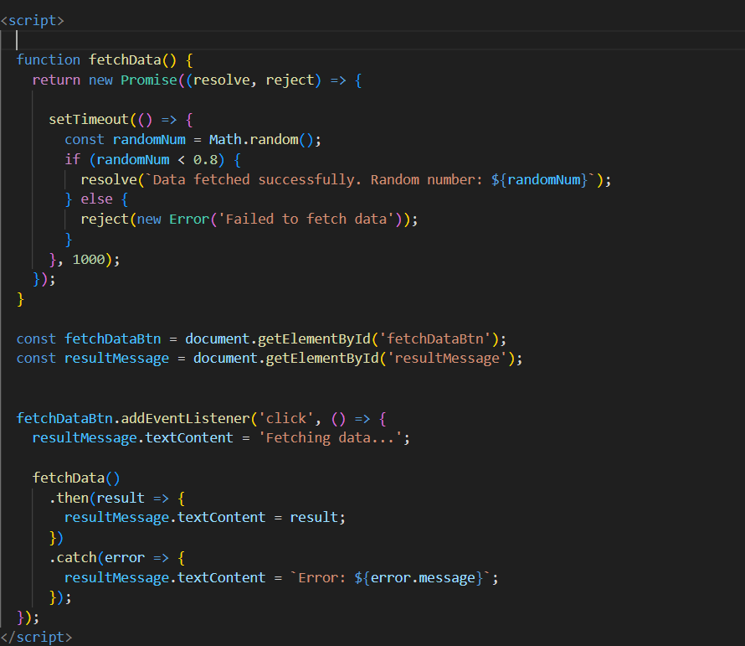

Q-4 Use fetch method for calling an api https://fakestoreapi.com/products

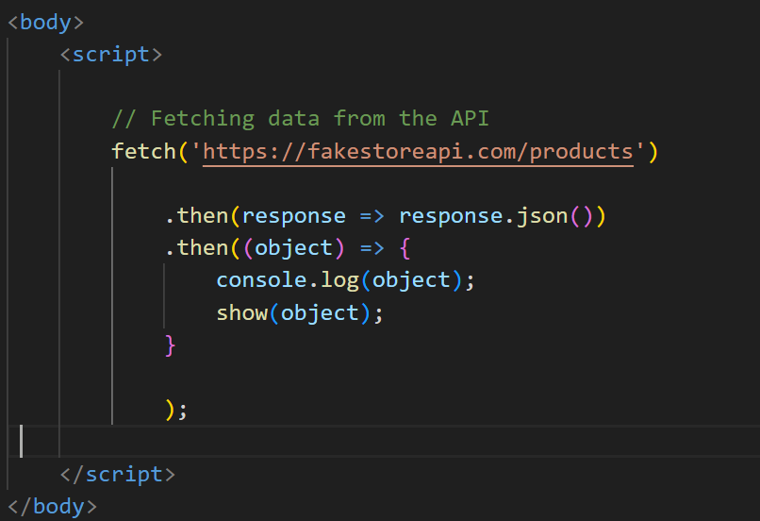

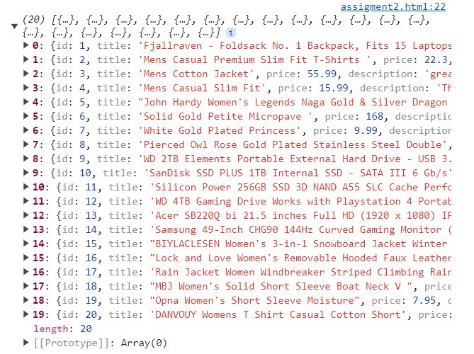

Q-5 Display all the product from the api in your HTML page

